OOD2 “Digital Circuit” Project

U
R
S

Version: 1st craft
Authors: Group 7 Jiaqi Ni, Kalina Petrova, Lumin Fan, Hasan Lapa, Ishant Upadhyay

Table of Contents
- Introduction………………………………………………….….2
- Functional Requirement....………………………………….2
- User-Interface………………..………………………………3
- Non-Functional Requirements ………………………………3

Introduction
To build a small digital circuit, we use some kind of gates: AND, OR, NOT, SOURCE and SINK. Gates can be connected by connections. With the above mentioned kinds of gates and connections it is possible to make simple circuits.

Functional Requirement
Will have:
Use case name: New file
Actor: User
MSS:
User chooses the ‘File - New Project’ option
- The system asks the user for confirmation.
- The system opens a new file.
Extension:
  - User clicks ‘No’ option, the system stays in the old project instead of creating a new one.

Use case name: Save file
Actor: User
MSS:
- User chooses the ‘File - Save’ option.
- System saves the file (Overrides existing file)
Extension:
2a First time saving this file.
System asks where to save file and with what name. (Refer to Save file as use-case.)
2b System could not find required space to save file.
The file is not saved.

Use case name: Save file as
Actor: User
MSS:
- User chooses the ‘File - Save As’ Option.
- The system shows a pop up to ask for the file name and location form user
- User browses for a specific location
- User enters specific name
- User clicks the ‘Save’ button
- The system saves the file
Extension:
5a. Name already exists for that file type in specified location.
System asks actor if it should override existing file.
- User overrides file.
- User searches for a new location or saves with a different name.
5b.There is not enough space to save this file. -> The file is not saved and still running until there is enough space to save or the actor chooses to close without save. (Refer to close use-case)
Save file.
Use case name: Open
Actor: User
MSS:
User chooses the ‘File-Open’ option
- The system opens a pop up window to choose the location and the name of the file.
- User looks for the file name.
- The system opens the File successfully
Extension: None
Use case name: Close file
Actor: User
MSS:
- User choose the option to close the file.
- System closes the file.
Extensions:
2a. If the file is not saved.
System asks the Actor if he wishes to save the file.
- User chooses to save file ->Refer to the Save file use-case.
- User does not want to save the changes. -> The system just closes the file.

Use case name: Quit
Actor: User
MSS:
- User chooses the ‘File - Quit’ option.
- The system asks the user for confirmation.
- The system quits.
Extension:
  - User clicks ‘No’ option, the system will not quit.
  - There are files that have been edited without being saved.
The system asks if you want to save opened files.
->User may close all files without saving.
->User may choose to close each file separately. (Refer to close use-case.)

Use case name: Add source
Actor: User
MSS:
- User chooses to add source
- User drags icon to specific field
- System asks what output would the source have
- User chooses output
Exceptions:
2.1 Cell is occupied by another gate
->System doesn’t allow user to place icon there
2.2 Cell overlaps with a path
->System checks if it can redirect path
->System redirects path
->System doesn’t allow user to place source there
Use case name: Edit source
Actor: User
MSS:
- User chooses a source
- User right clicks on source
- User chooses he wants to change source value
- User clicks on value he wants to change source to
- System changes the source’s value
- System makes appropriate changes in sink values
Exceptions:
  - Chosen source value is the same as before
->System leaves the values of the source and the affected sinks alone

Use case name: Delete source
Actor: User
MSS:
- User right clicks on source
- User chooses option to delete source
- System asks user if he’d like to remove the source
- User clicks ok
- System removes source
- System removes connecting links
- System changes sink values accordingly
Exceptions:
  - User clicks cancel
    - System returns back to grid
  - Removal of source influences other gates (For example we have a AND b and we’d like to remove a we’ll be left with only AND b)
    - System sends appropriate message
    - System asks user if he’d like to remove influenced gates
->User clicks ok
->User cancels request

Use case name: Add gates
Actor: User
MSS:
- User chooses what gate to add
- User drags icon to grid
- System places gate in specified cell
Exceptions:
  - Cell is occupied by another gate
    - System doesn’t allow user to place gate there
    - User chooses another cell to place gate
  - Cell overlaps with a link
    - System checks if it can redirect link
->System changes path of link
->System doesn’t allow user to place gate there

Use case name: Delete gate
Actor: User
MSS:
- User right clicks on a gate
- User chooses to delete gate
- System asks user if he wants to delete gate
- User clicks ok
- System removes gate
- System removes links connected to gate
- System changes sink values accordingly
Exceptions: none.

Use case name: Add sink
Actor: User
MSS:
- User chooses to place a sink
- User drags icon to specific cell
- System places sink on specified cell
- By default system sets value of sink to 0
Exceptions:
3.1 Cell is occupied
3.1.1 System doesn’t allow user to place sink there
3.2 Cell overlaps with link (path)
3.2.1 System checks if it can redirect path
->System redirects path
->System doesn’t allow user to place sink there

Use case name: Delete sink
Actor: User
MSS:
- User right clicks on sink
- User chooses to delete sink
- System asks user if he’d like to remove sink
- User clicks ok
- System removes sink
- System removes connections
Exception: None.

Use case name: Add connection
Actor: User
MSS:
- User chooses to place a link
- User clicks on one gate
- User clicks on the second gate
- System connects gates
- System redirects path so it avoids overlapping with other gates
- System redirects path so it doesn’t overlap with other links
- System changes values to sinks accordingly
Exception: None.

Use case name: Delete connection
Actor: User
MSS:
- User right clicks a link
- User chooses to delete link
- System asks user if he’d like to remove link
- User clicks ok
- System removes link
- System changes sink values accordingly
Exception: None.

Could have:
Use case name: UNDO
Actor: User
MSS:
- User clicks the ‘Edit-UNDO’ option.
- System undoes the last operation.
Exception: None.

Use case name: maximize
Actor: User
MSS:
- User clicks the Maximize option.
- System’s form maximized.
Exception: None.
User - Interface
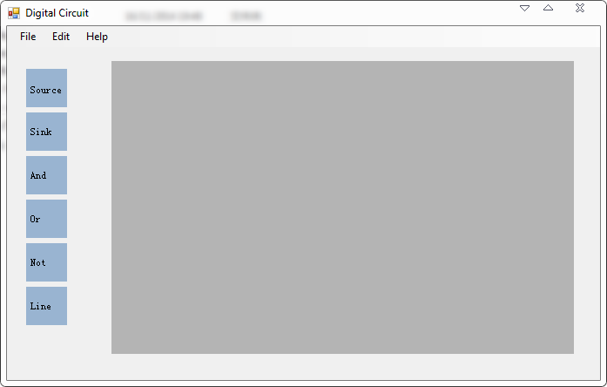

Non - Functional Requirements
- Windows is the only supported OS.
- It will take 2MB of your storage.
- No specific requirements for hardware.
- In case any error happens (not responding for 5 seconds), windows should be able to force it stop.

